Student Internship Reflection Assignments - Charger Link

- Once your internship has been approved, login to the new Charger Link, powered by AcadeME in myCharger

Once logged in to myCharger, click on Student Life in left hand nav bar
Click on ‘Career Development Center’ on the right side
Access Charger Link

- Upon entering the system, click the ‘Internship’ button in bottom left corner of screen
- Click on ‘Internship Update & Follow Up Report’
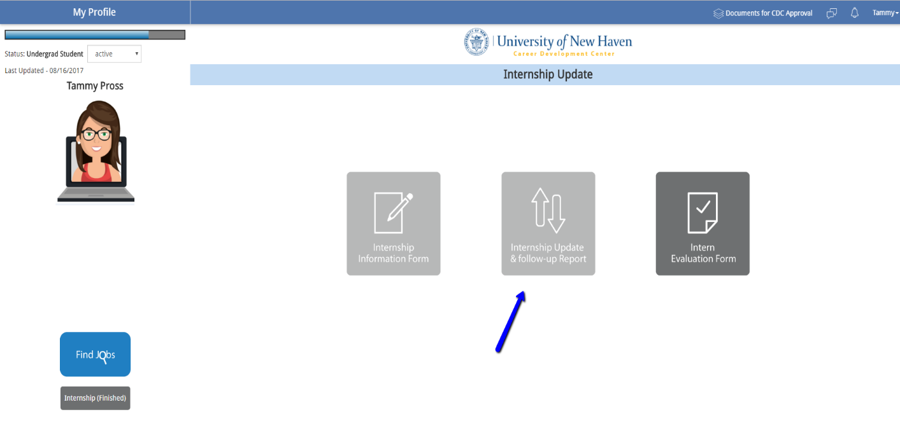
- Enter your internship reflection assignment, as determined by your advisor (weekly/monthly/etc.) and your hours worked for the time period
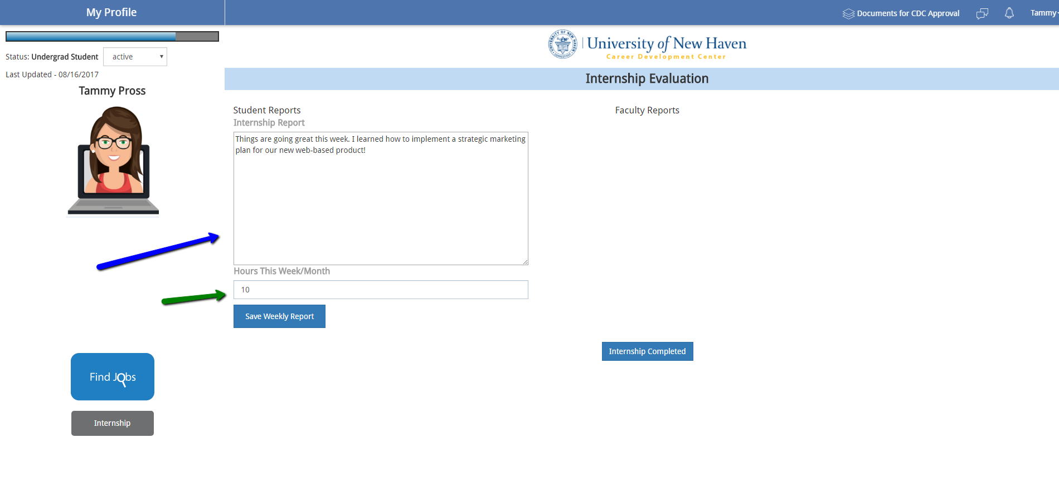
- Your faculty advisor will review and can respond to your assignments
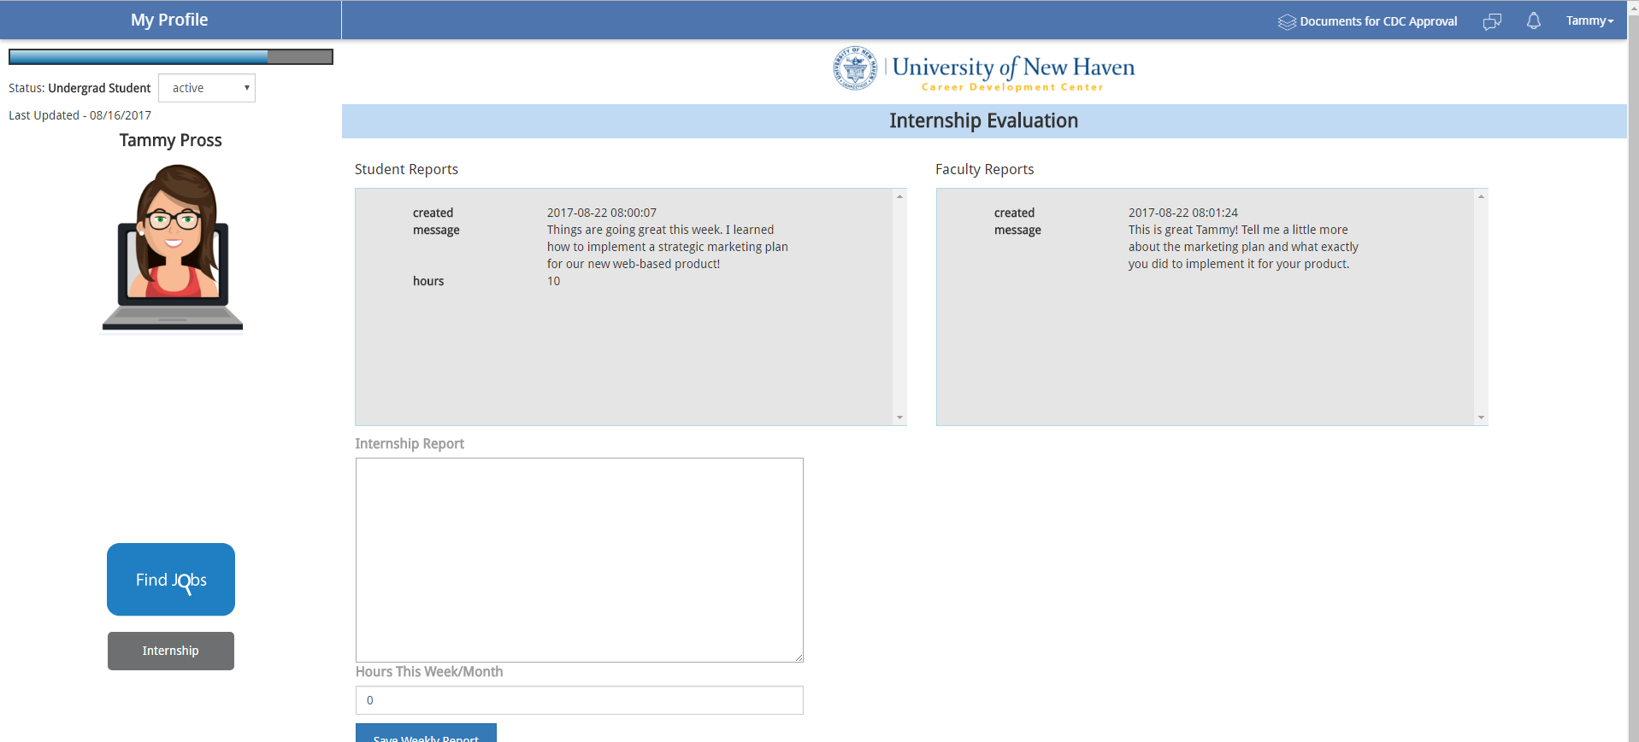
- Upon completion of internship, push ‘Internship Completed’ button
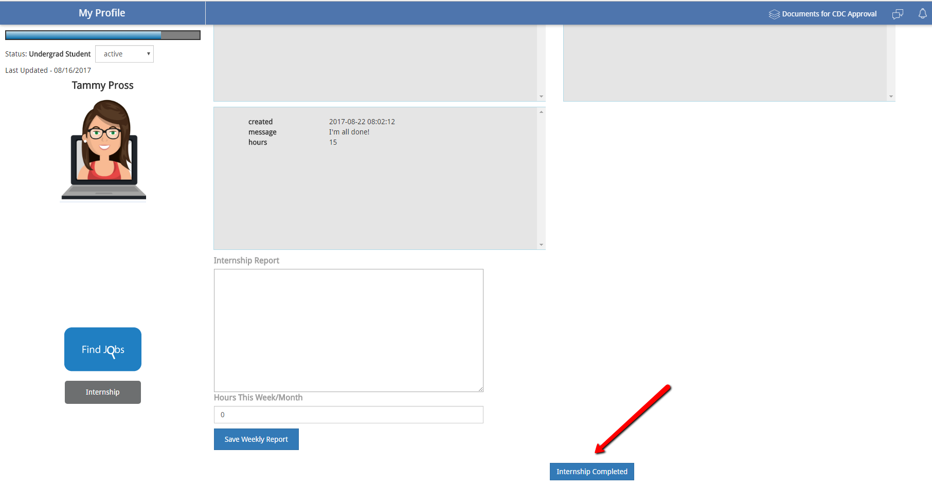

- If your advisor is using an evaluation form, click on ‘Intern Evaluation Form’ to download and complete per your advisor’s instructions
